AMERICAN HERDING BREEDS ASSN.
AND

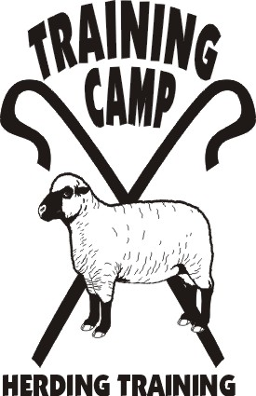

COURSES OFFERED:

HERDING ARENA TRIAL
HERDING RANCH TRIAL MIXED FLOCK

May 28, 2012

LOCATION:

Seaman Farm, Chisago, MN

OPEN TO ALL HERDING AND MIXED HERDING BREEDS
(DOGS AT LEAST 6 MONTHS OF AGE)

TRIAL CLASSES: HTAD I, II, III – Ducks
Course 4 w/gather & shed
HTAD I, II, III – Sheep
Course 4 w/gather & gate sort
HRD MF I, II, III – Sheep/Goats/Ducks

ENTRY LIMITS: 20 HTAD – Sheep
15 HTAD – Ducks
7 HRD - Mixed Flock

JUDGE: Becky Beckmann

MAIL ENTRIES TO:
Julia Torgersen
5416 – 245th St.
Forest Lake, MN 55025

ENTRY FEES HTD & HTAD CLASSES:
PRE-ENTRY (Due May 15, 2012) $30/run
Day-Of (livestock available) $40/run

HRD Mixed Flock - $40/run

TRIAL CHAIR: JoAnna Yund
JoAnnaY@aol.com

- Handlers Meeting for Ducks will be at 7:30 a.m.
- Handlers Meeting for Sheep will be at 10:00 a.m.
- Handlers Meeting for Ranch will be at 2:30 p.m.
- Competitors are responsible for cleaning up after their dogs. All dogs must be on leash when not competing.
- Competitors assume financial responsibility for medication and/or veterinary care and/or replacement value of stock for any injury caused by them or their dog(s).

DIRECTIONS TO SITE – available at www.trainingcampinc.com

